Preliminary Result of Paper 2; Aggregation Method A

June 27, 2019

## Table 1

Demographics of the ever had relapse vs never had relapse.

|  |  |  |  |
| --- | --- | --- | --- |
|  | Ever had relapse | Never had relapse | p-value for heter |
| Total number of patients | 1672 | 703 | NA |
| Num belongs to EHR | 1047 | 508 | NA |
| Sex (% female) | 73.8 | 71.4 | 0.233 |
| Race (% white) | 92.5 | 93 | 0.69 |
| Median (IQR) age at first code | 33.4 (15.5) | 39 (15.3) | 4.3e-14 |
| Median (IQR) age at first symptom onset | 32.9 (15) | 33 (13.9) | 0.846 |
| Median (IQR) age at first date | 33.6 (16) | 35.9 (15.2) | 5.8e-05 |
| Median (IQR) duration of follow-up | 12.7 (12.5) | 16.9 (15.6) | 7.1e-24 |
| Median (IQR) number of treatments | 2 (2.2) | 0 (2) | 0.0e+00 |
| % receiving treatments | 95.5 | 44.1 | 7.4e-182 |
| Average Annualized relapse rate 2000-2016 | 0.222 (0.005) | 0 (0) | NA |

## Data Manipulation

For each encounter, it is classified as a case if the corresponding patient experienced relapse within 6-month window. The overall case rate is 0.164.

We further take a case-control subsample as following. For each patient, his or her follow-up period (enrollment date or first encounter date, whichever comes first) are cut into 3-month time windows. Only one case/control will be sampled from cases/controls within the same 3-month time window. The overall case rate among this subsample is 0.149. No big difference.

## Correlations

## Perfect correlation between CUI.C1304680 CUI.chip0104   
## CUI.chip0104 deleted.

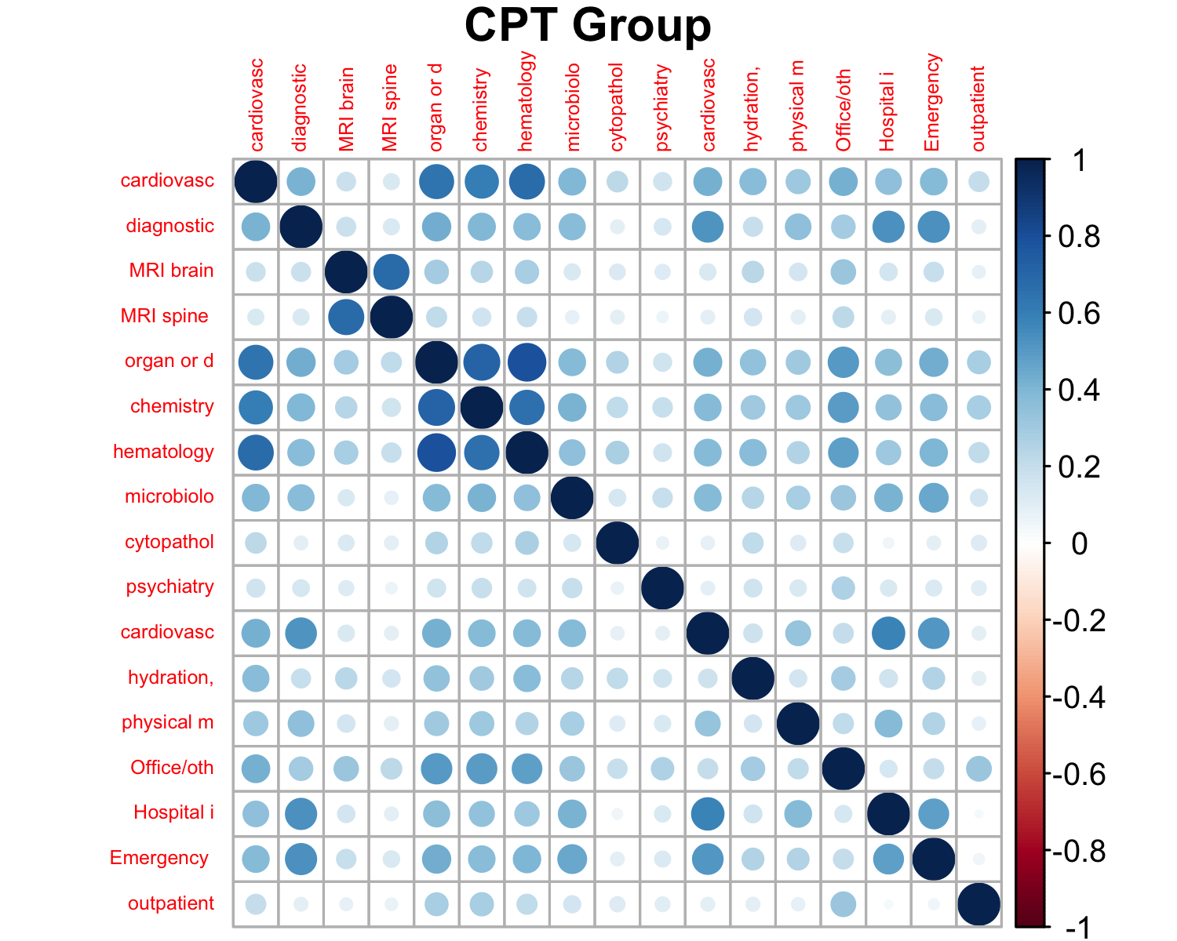

## Among CPT Groups:

## Min. 1st Qu. Median Mean 3rd Qu. Max.   
## 0.03003 0.14423 0.24103 0.27501 0.38068 0.79592

## CPT Group vs others:

## Min. 1st Qu. Median Mean 3rd Qu. Max.   
## 0.02357 0.17127 0.26384 0.28005 0.36729 0.77845

|  |  |  |
| --- | --- | --- |
| CUI | CUI | Corr |
| C0030193 | C0311392 | 0.850 |
| C0032743 | C0949766 | 0.981 |

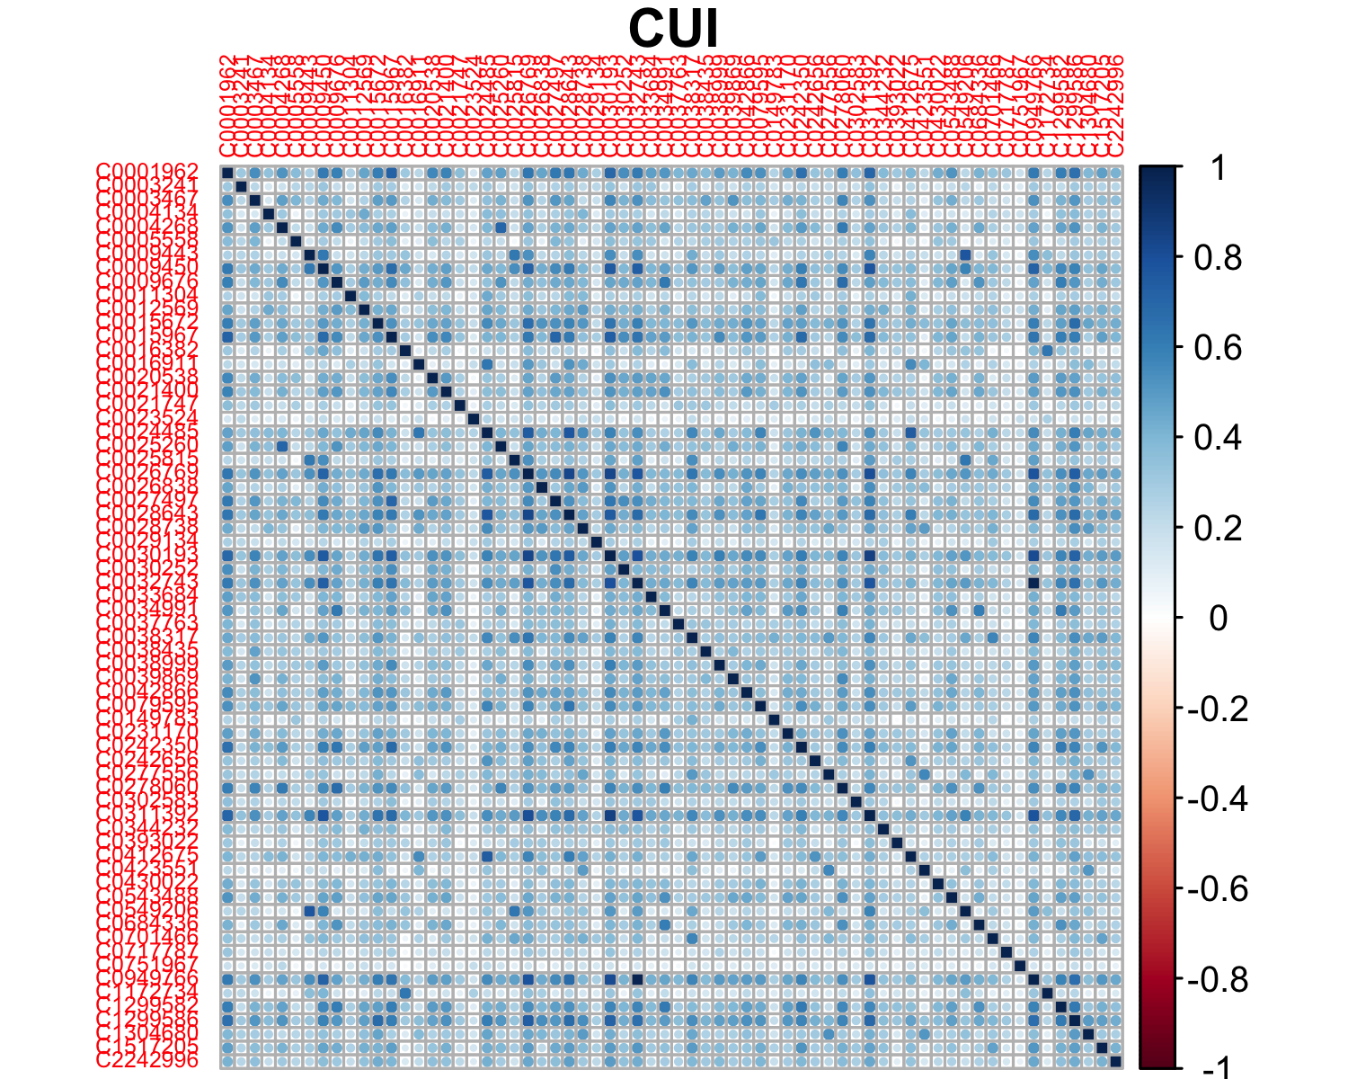

## Among CUIs:

## Min. 1st Qu. Median Mean 3rd Qu. Max.   
## 0.02555 0.20392 0.30198 0.31861 0.41452 0.98149

## CUI vs others:

## Min. 1st Qu. Median Mean 3rd Qu. Max.   
## 0.009351 0.171266 0.265346 0.279835 0.367301 0.857854

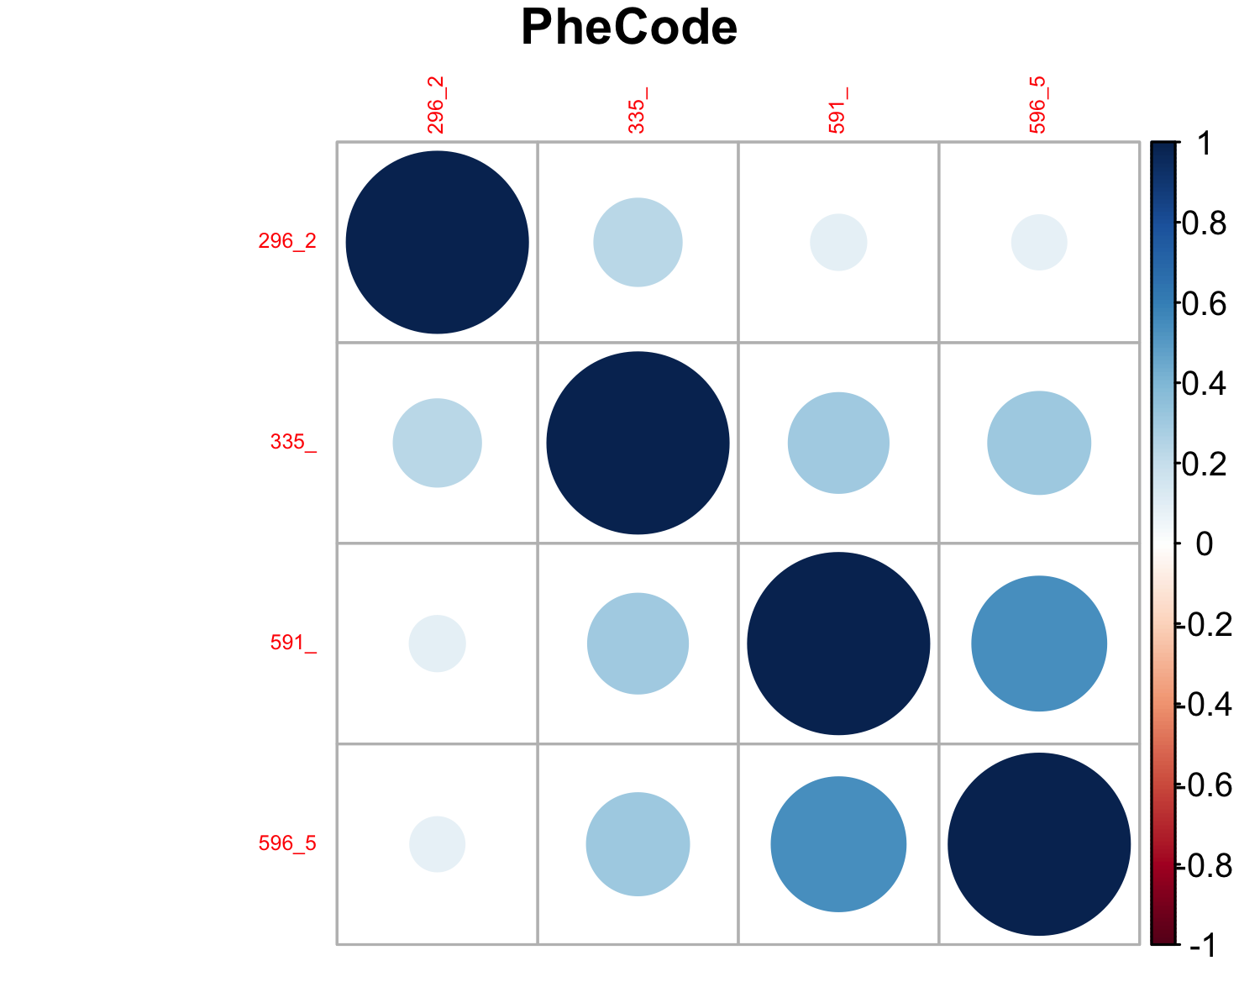

## Among PheCodes:

## Min. 1st Qu. Median Mean 3rd Qu. Max.   
## 0.08816 0.12636 0.26597 0.26205 0.31220 0.54477

## PheCode vs others:

## Min. 1st Qu. Median Mean 3rd Qu. Max.   
## 0.009351 0.165116 0.275441 0.281384 0.375859 0.857854

## LASSO model with optimal (in the sense of minimize deviance) lambda (tuning parameter)

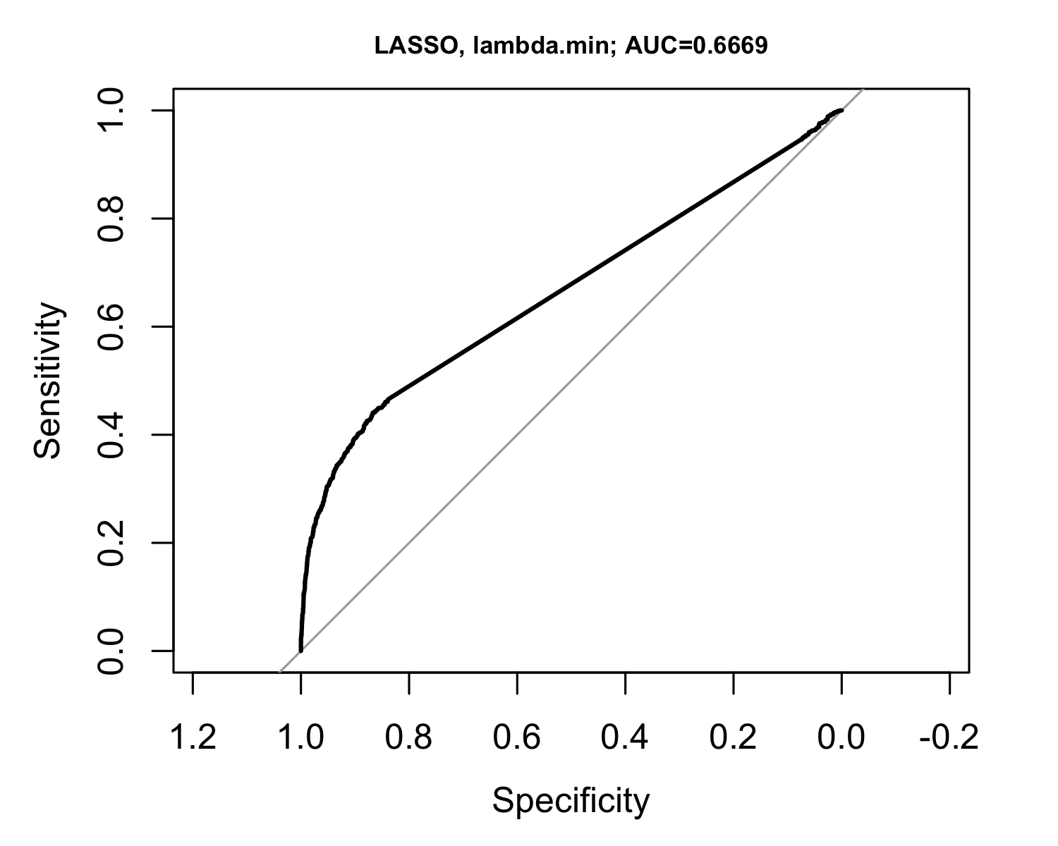

## LASSO model with optimal (in the sense of minimize deviance) lambda (tuning parameter) + one standard error

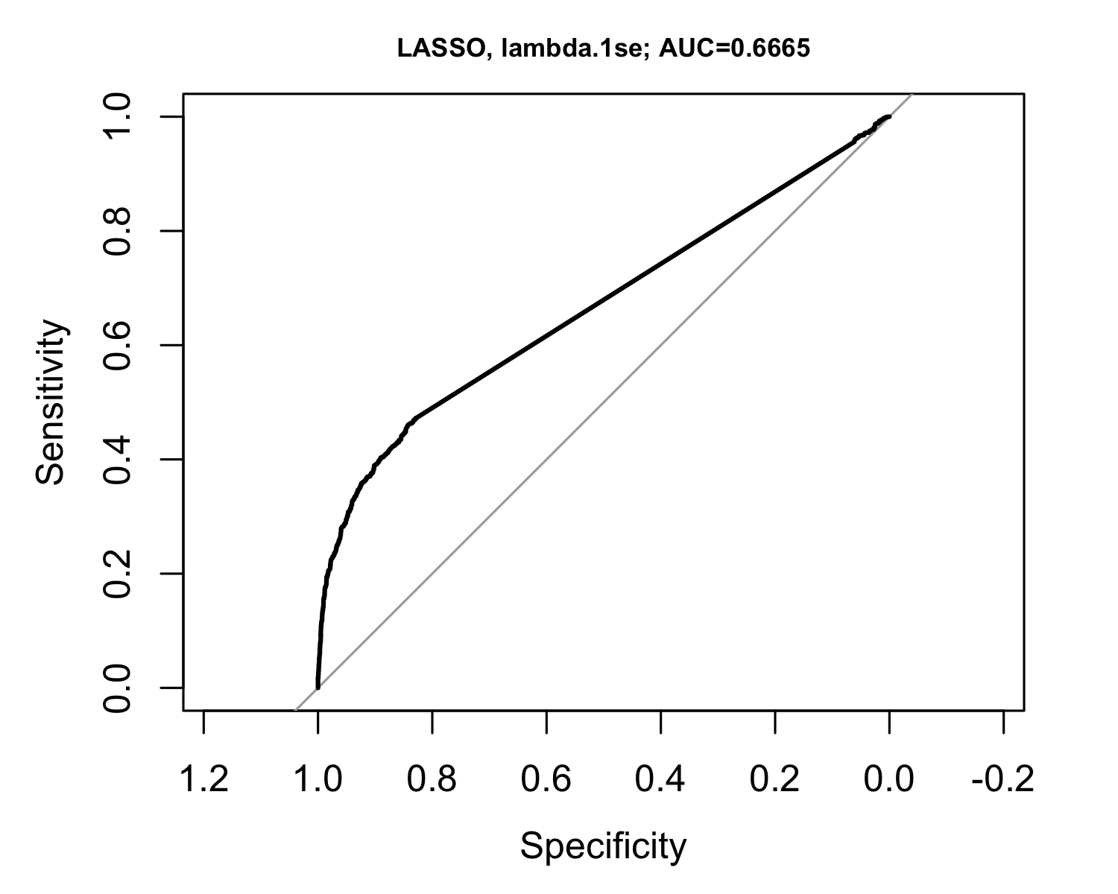

## Random forest

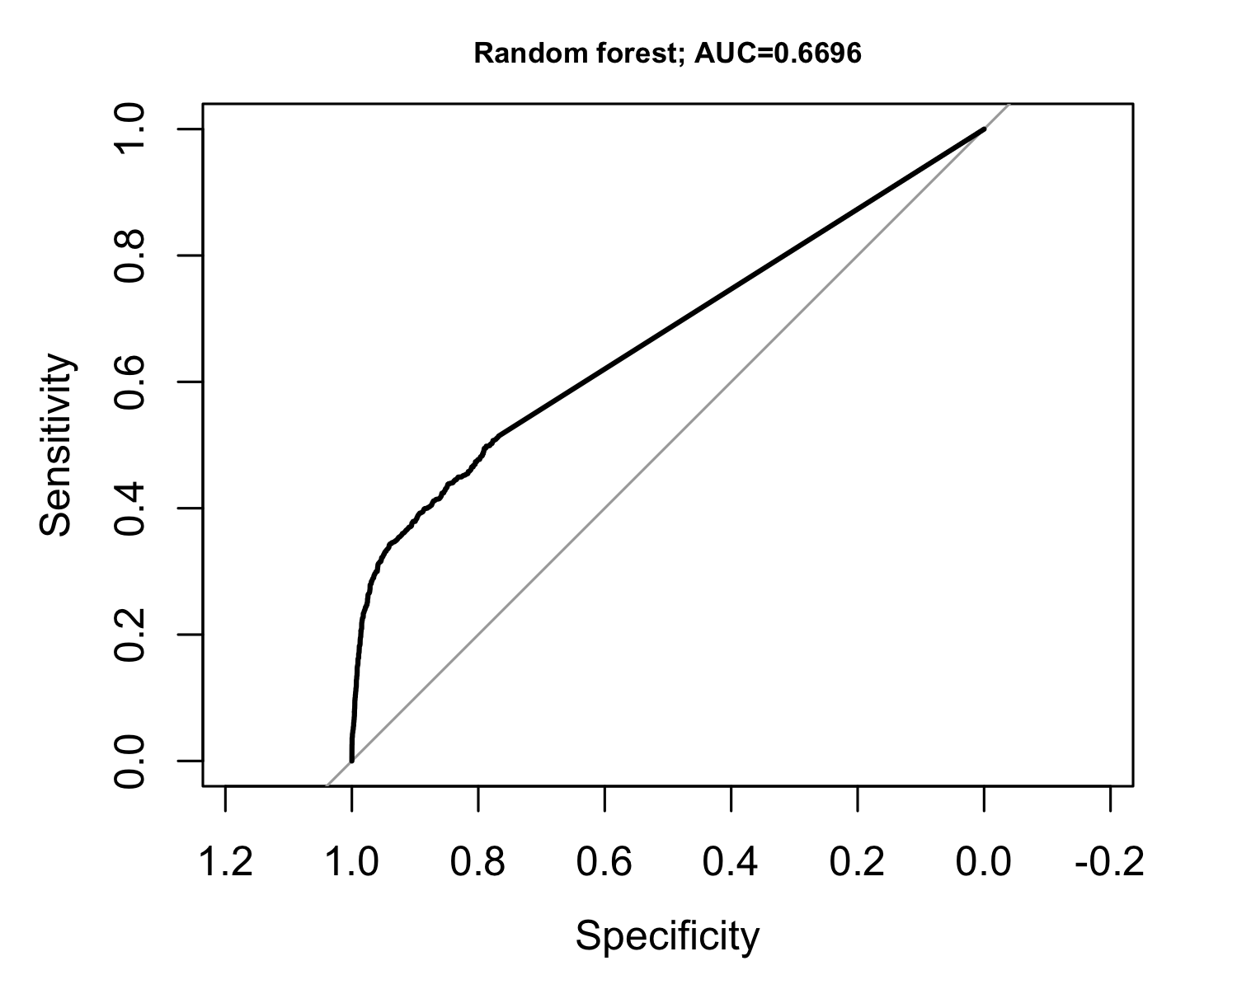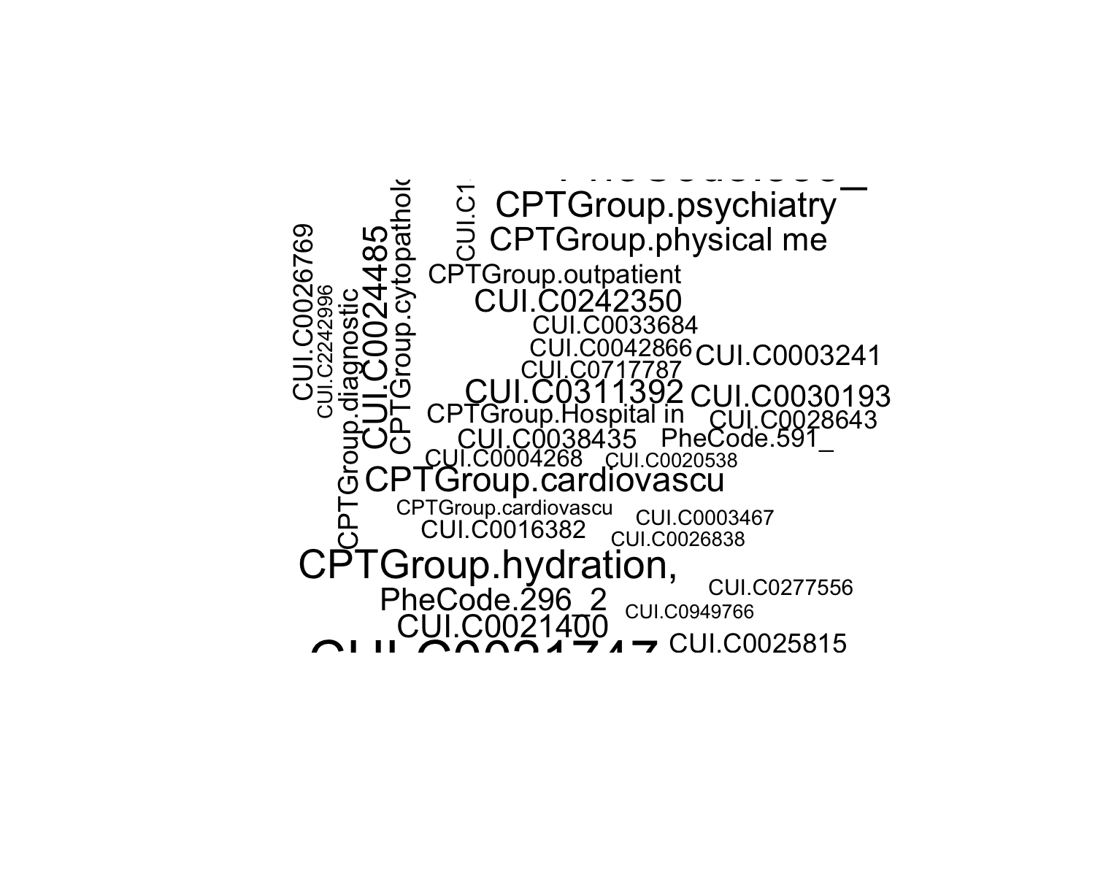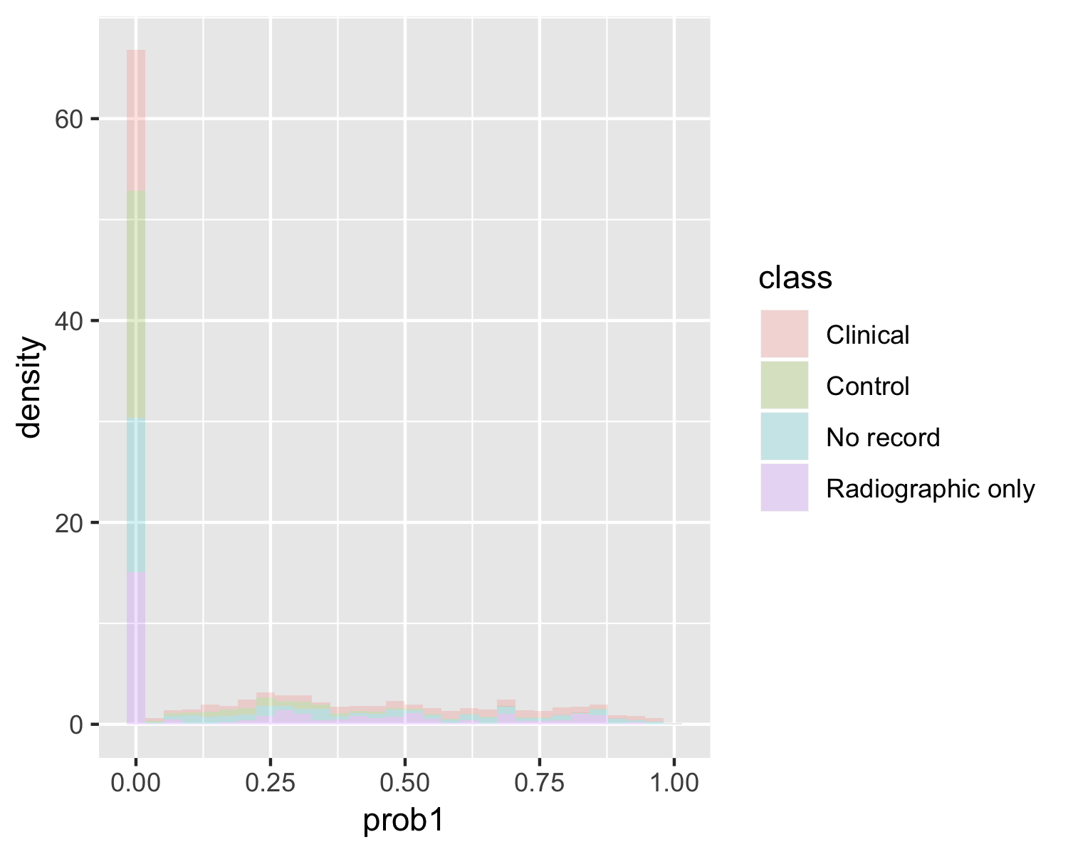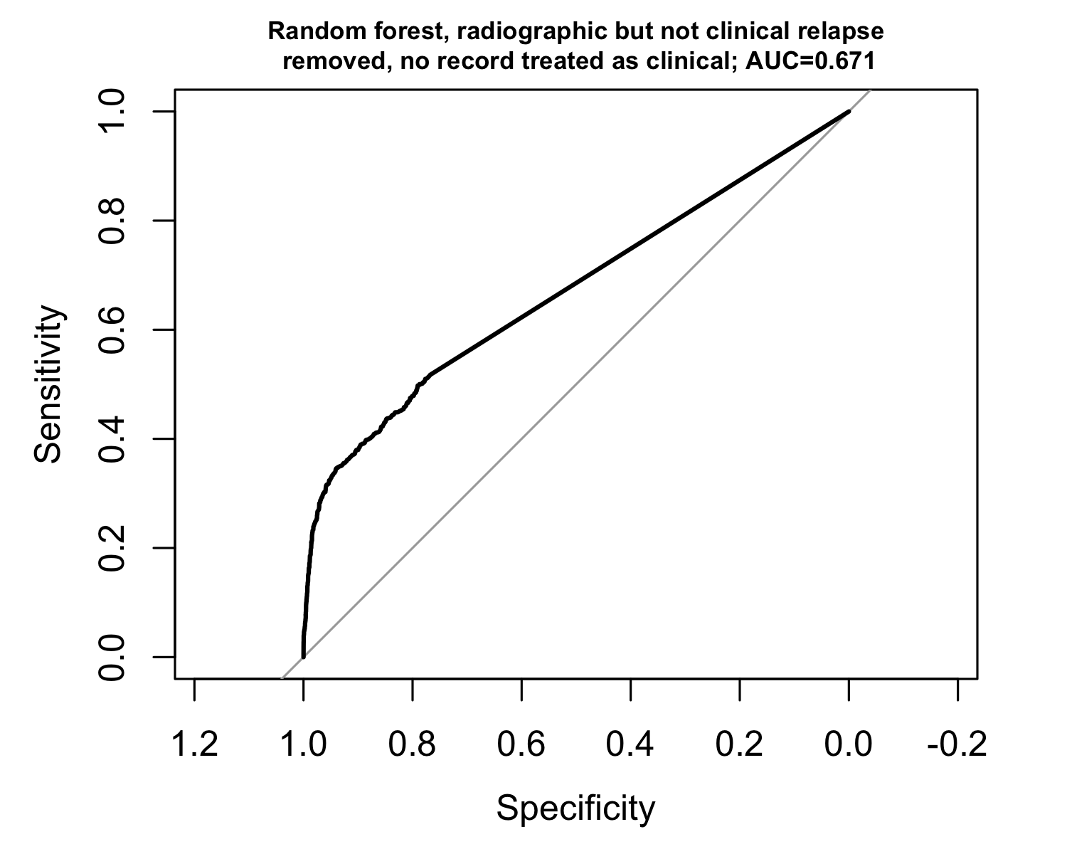

## Ensemble logistic regression (LASSO) with random forest

